Hokotehi Moriori Trust

2011 Peace Congress
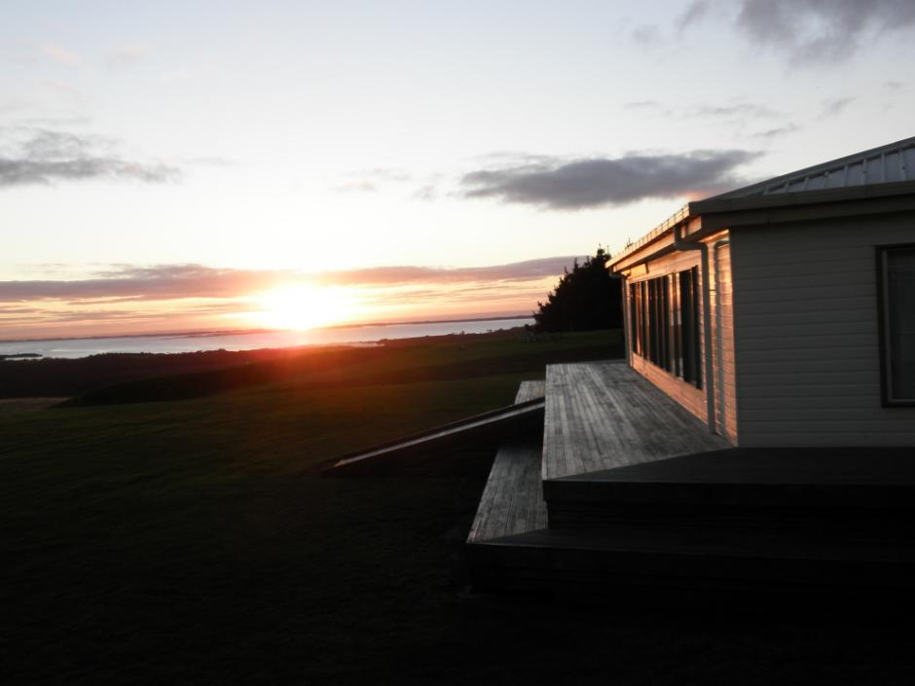

REGISTRATION BROCHURE

CONTENTS

WELCOME MESSAGE 3

ABOUT THE CONGRESS 4

ACCOMMODATION 5

TRANSPORT TO THE ISLAND 6

DRAFT PROGRAMME 8

WORKSHOP FACILITATORS 9

REGISTRATION FORM 11
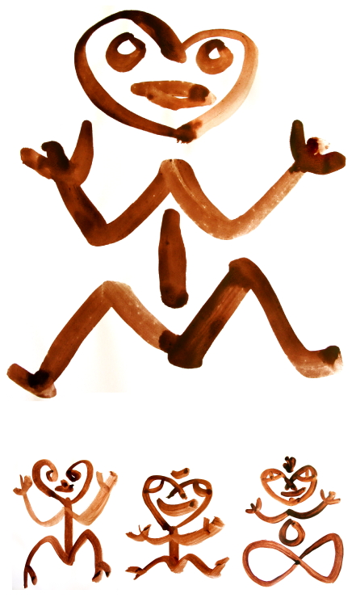

WELCOME MESSAGE FROM YOUR HOSTS
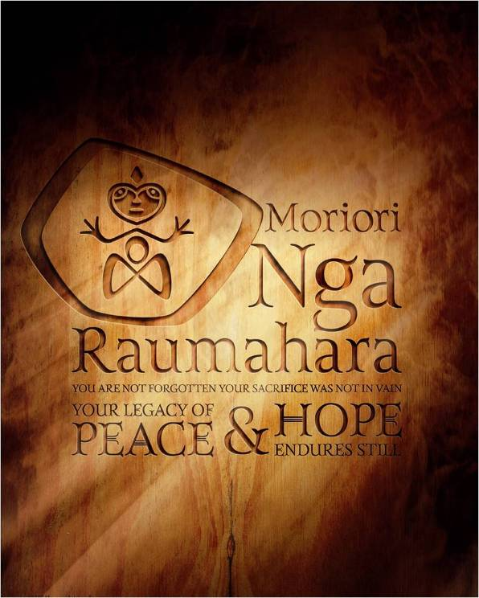
Hokomenetai, me rongo. In a spirit of unity and peace it is a pleasure to welcome you to the first “Peace, Sustainability and Respect for the Sacred” Congress. In a sense, the Congress has been an event that has been part of the cultural identity of these islands for hundreds of years. A commitment to establishing and holding on to a covenant of peace and conflict resolution has been in place on Rēkohu for over 500 years – the world’s oldest known consistent peace tradition.
Moriori regularly held gatherings to affirm the covenant, particularly in response to crises. This Congress only differs in that we are gathering from around the globe.
In 2009 Hokotehi held the blessing for the World March for Peace and Non-Violence and then attended the close of the march in Punta de Vacas, Argentina three months later. Last year, Hokotehi facilitated a Congress session on Peace, Sustainability and Respect at the 12th International Society of Ethnobiologists Congress in Tofino, Canada where we were joined by presenters from the Hopi Nation and Kanaka Maoli from Hawai’i. This Congress aims to build on these special events and become a regular learning experience (every second year) in the lead up to the creation of an international Peace Education Centre on the island.
This Congress is possibly different from most you will attend. Accommodation is marae-based and communal. The congress presentations will flow into evening performance and entertainment as part of the sharing of a wider collective of peace traditions. Listening to and learning from our elders will be the primary focus. It has also been blended with weeks of workshops on writing, art, resilience, healing and creativity. Our philosophy behind this is to create something tangible and relevant for our remote island community and to ensure that the scene is set for a productive peace congress.

Me rongo (with peace)

Maui Solomon
General Manager and Congress Director
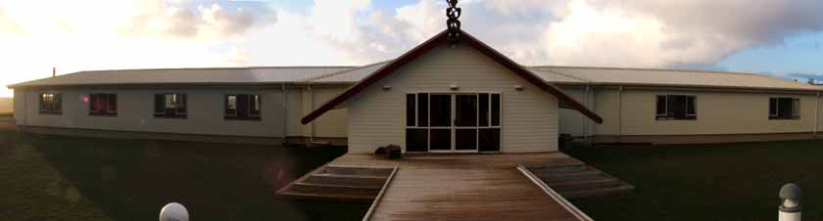
Hokotehi Moriori Trust

ABOUT THE CONGRESS
Me Rongo is a Moriori term meaning “in peace”. It is used as both a salutation and affirmation. The word “rongo” also embodies other vital ingredients for peaceful living, as rongo means “to listen”. Me Rongo implies that in order to be in peace, one must also listen and listen deeply and respectfully. This listening is not just amongst people but also incorporates a deeper listening to the rhythms and sounds of the living systems of which we are a part.
In May 2010, a gathering was convened in Tofino Canada as part of the International Society of Ethnobiology’s 12th International Congress. The Tofino gathering was conceived as a stepping stone in the lead up to the Me Rongo Congress planned for November 2011. The Tofino gathering was held in an indigenous centre and named Hishuk-ish tsa’walk after a Tla-o-qui-aht expression meaning “everything is one”.
The session (entitled “Peace, Sustainability and Respect for the Sacred”) brought together elders and other experts from around the world who have traditions in peace keeping/making as an integral part of their philosophy. It focussed on the importance of the preservation and transmission of inter-generational knowledge of "living in country" as the Aboriginal peoples of Australia say, and the maintenance and promotion of retention of the local language(s) and cultural practices of the communities that sustain this knowledge. At its heart was an understanding of the importance of the sacred/spiritual/wairua traditions – as an expression of the thread that binds people together with their natural worlds, and which provides the basis for living in a mutually respectful and mutually enhancing relationship of humans, plants and animals.

In addition to providing a collective forum for learning about peace traditions and the importance of being able to practice cultural continuity, the session examined ways in which the modern world may come to a better understanding of how this sacred knowledge or knowledge of the sacred is critical to humankind (re)learning how to live "in connection with" rather than increasingly "disconnected from" our planet and planetary systems.

Me Rongo November 2011

The Me Rongo Peace Congress aims to reunite people involved in the World March and the Tofino Peace gathering as well as others involved in peace-making or who have peace-making traditions, on Rēkohu in November 7-21, 2011.

The vision for the Peace Congress is to create a meaningful and lasting practice of mindfulness amongst all who attend. We believe that when you have hope for future generations, peace prevails. The Moriori message of peace is something we are proud of and wish to share with the rest of the world, as a beacon of hope.
In a world of increasing ecological strain and decreasing resilience island communities are often the first to feel the effects. Dependency on imports for sustenance and exports for economic survival can contribute to community fragility. However, there is another way to confront environmental and community problems associated with ecological decline, violence and lack of respect. We believe that island communities can be effective models of transition communities for larger nations to follow. If Rēkohu can achieve this then many other nation states can as well.
The main objective of the Congress is to gather peace makers together (physically and by video-link) in order to draft a Rēkohu Peace Declaration based on principles of sustainability and respect for the sacred. A critical part of this declaration will be a synthesis of conflict resolution methods discussed at the Congress.
We are very conscious of the need to have enduring and relevant outcomes that help make a difference to this island community as well as for communities of attendees. Recent seismic activity around the Pacific, including dramatic and disastrous earthquakes in Christchurch New Zealand and Japan have reinforced the need for developing community resilience. Accordingly one of the core objectives will be to develop a transition plan for Pacific nations, based on the notion of transition communities.
The Congress is fully endorsed by the Hokotehi Board of Trustees:
- Mrs Shirley King (Chair)
- Mrs Lin Entwistle
- Mr Greg Preece
- Mr Aaron Donaldson
- Mr Dennis Solomon
- Mr James Matenga
- Mr Brian Solomon
- Ms Amanda King

ACCOMMODATION
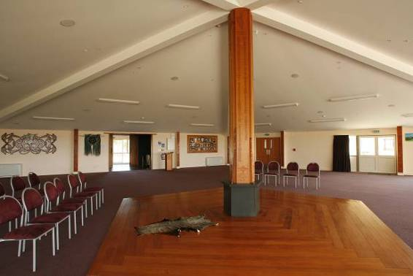
Attendees at the Congress will be hosted at Kōpinga Marae and Henga Lodge – both owned and operated by Hokotehi Moriori Trust. The marae provides communal accommodation in a traditional layout but with modern kitchen, bathroom and wireless internet facilities. Henga Lodge is a comfortable venue with accomodation for about 20 people. Some of the workshops and events will be at the Lodge venue with daily shuttle transport between Lodge and Marae.
Congress attendees will not be charged for staying at the marae apart from contributions towards meal costs.
The design of the marae is based on traditional values and concepts but built with contemporary materials. The pentagonal design is inspired by the 5 sided basalt columns on Rekohu where Moriori made their adzes and other tools and also reflects that Moriori traditionally met in large circular open air gatherings among Kōpi trees (such as those at Te Awapatiki). The ‘arms’ extending either side of the main whare (for kitchen/dining on the left and office space and bathrooms/laundry on the right) represent the arms of a carved ‘rākau momori’ tree figure of a human as seen from old tree carvings. From the air the building looks like a large hopo or albatross in flight. The hopo is culturally significant to Moriori as a source of food but also a source of spiritual inspiration. Moriori wore the feathers of the hopo in their hair and beards as symbols of peace. Stone patu were also made in the shape of young hopo.

Kawa (protocols) – First time visitors to Kōpinga will be welcomed with a hokomaurahiri which enables visitors to be greeted respectfully and become connected to the place. The ceremony will take place around the tūahu. Moriori elders will speak and welcome you, then offer an opportunity for you to reply. Women may speak and any language may be used. It is good custom to follow your response with an appropriate song. The Tūahu is a place where gifts and tributes are placed. If you wish to bring a symbol of peace or something from your country you are welcome to place your gift on the tūahu during the welcome. This ceremony is also the appropriate time for the offer of koha (donation towards hospitality). The hokomaurahiri always concludes with a hongi (pressing of noses) and a meal or refreshments.

Facilities - Kōpinga is a 5-sided building so there is no designated space for visitors/home people. You may sleep on whatever side you prefer. We recommend you bring a small torch for finding your way around in the dark. Mattresses, sheets and pillow cases are supplied along with some duvets and blankets but we advise bringing your own sleeping bag and towels if you are part of a larger group. The marae is centrally heated and is always warm, whatever the weather. Wheelchair access is provided for most areas of the marae. Outside footwear must be removed as you enter the marae.

TRANSPORT TO THE ISLAND
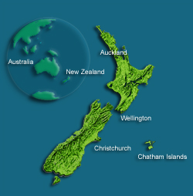
Travel to the islands is by plane (40 seater Convair) that flies directly from three New Zealand main centres (Auckland, Wellington and Christchurch). The flight takes about 1 hour 40 minutes. Special charter flights and airport transfer on the island will probably be arranged for attendees at the Congress. Please note that the airline is very strict about luggage weight limits – 20kg per person max. Check in for Air Chathams is through the Air NZ counters in Wellington, Auckland or Christchurch. You will be issued an Air Chathams boarding pass but there are no allocated seats. Climb aboard and let the adventure begin!
Rēkohu comprises a group of 10 islands (two of which are inhabited with people) located 800km east of New Zealand. The island group has been part of New Zealand’s sovereign territory since 1842 and contributes significantly to the New Zealand economy as a result of the 200 mile Exclusive Economic Zone around the island group in the rich fishing waters of the Southern Pacific Ocean. The main island (Rēkohu or Chatham) is about 90 km² and is home to about 600 residents. The smaller inhabited island (Rangihaute, or Rangiauria or Pitt) is 6 km² and home to about 45 residents. The centre of the main island is dominated by a large lagoon (Te Whānga). The islands are the only place in the world where the sky often re-connects with the land (hence the name Rēkohu, which means to look at the sun through misty skies). For those from the northern hemisphere, the islands are the antipodes of the French Languedoc-Roussillon area.
The islands are 45 minutes ahead of NZ standard time. They have a temperate climate year round, though are exposed to winds. Visitors are advised to bring warm and water-proof clothing. Currency is the $NZ and eftpos is available, though credit card use is limited to a few of the accommodation providers. Cell phone reception is not available but the marae and lodge have broadband internet access. There is an ANZ bank and P.O. on the island but no ATM machines. Shops include a garage, post office, gallery, food store, fruit and vegetable shops, and the local tavern, and lake-side cafe. The island has a small hospital for any medical treatment, but it is advisable to bring your own medicinal needs.
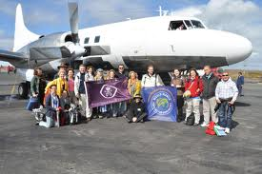
Island economy is principally based on fishing and farming industries, though tourism is growing. The islands are the traditional homelands for Moriori who established an enduring culture of peace that lasted on the islands for at least 25 generations. They are also renowned for their geologically diverse landscapes as well as habitats for rare and threatened bird and plant species.
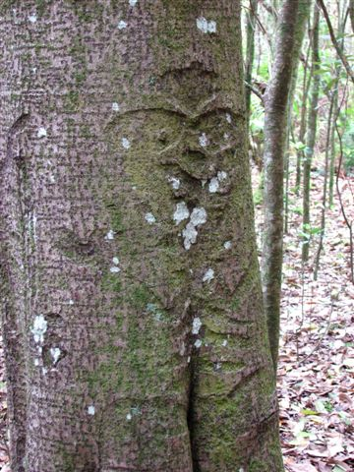
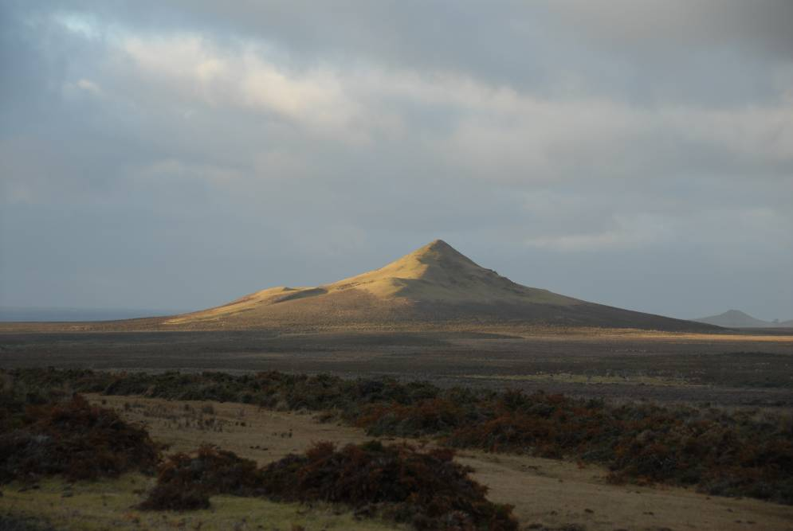
DRAFT PROGRAMME
Date/Time | Event
Nov 7 | Guests and attendees begin arriving on Rēkohu  Formal welcome to Kōpinga Marae  Rest and registration
Nov 8 | Trip to Hāpūpu for immersion in Moriori traditions and landscapes  Gathering of guests – international sharing of arts and traditions in a presentation and reciprocity evening at Kōpinga  Gift Exchange
Nov 9 | Workshops commence on writing, jewellery, clay art, bone carving, painting and sculpture (5 day workshops)  Introductory workshop on permaculture and organic gardening  Planting of sacred groves and peace garden commences
Nov 10 | Tours of the island and talks from Moriori elders  Half day workshop on permaculture design at Kōpinga or Henga
Nov 11 | Acknowledgement of Armistice Day (11.11.11)  Artist workshops continue  Opening of the Peace Congress – parallel sessions and key note speakers  Evening performances
Nov 12 | Peace Congress  Artist workshops and evening music performances
Nov 13 | Conclusion of the Peace Congress  Drafting of the Rēkohu Declaration
Nov 14 | Artist workshops and evening film screenings (Peace and Respect for the Sacred)  Introductory workshop on transition communities  Planting of sacred groves and peace garden
Nov 15 | Half day workshop on transitioning away from fossil fuels and waste management for Rēkohu (and island communities)
Nov 16 | Artist and writers workshops continue
Nov 17 | Artist and writers workshops continue
Nov 18 | Artist and writers workshops continue
Nov 19 | Artist and writers workshops continue
Nov 20 | Auction and gifting of finished art works  Closing ceremonies and farewells
Nov 21-22 | Optional tours of the island

WORKSHOP FACILITATORS
Indigenous elders with peace-making traditions will be a primary focus of this Congress. Attendees will hear from Moriori elders, as well as elders from around the Pacific, the Hopi Nation, Canada and Asia. Key note speakers will be confirmed when Congress abstracts and presentation outlines are received.
We are planning to include opportunities for two-way video link ups for those interested in being part of the Congress but who may not be able, or not wish to travel. On a remote island this is not a simple process but we aim to confirm details with the final conference programme. The Congress website will also contain news updates on this item.
Presenters have been asked to provide abstracts for presentations with key themes of the Congress. Presentation proposals are welcome for sessions that are between 20 and 60 minutes. These may run as interactive workshops or as traditional presentations. Power-point and AV equipment will be available. Presentation Posters are also welcome. We plan to have an exhibition of congress poster presentations on display throughout the month. Guidelines for posters are relaxed in terms of size but please make sure your presentation is suitable for travel. Congress themes are:
- Peace and ethics
- Eradication of weapons and instruments of aggression
- Peaceful conflict resolution
- Peace education
Abstracts and presentation outlines are due by 1 September 2011
Workshops will be held on the following topics. You will need to register your interest in these as spaces will be restricted for some of them. Registration details can be found in the form at the end of this document. High levels of interest in workshops may see the congress timetable adjusted to meet your needs.
These workshop presenters are some of the most respected artists, ecologists and writers in New Zealand. We are honoured that they have agreed to participate in this Congress.
If you wish to facilitate a workshop please contact the Congress Coordinator by 1 August 2011
Contact: Susan; salala@paradise.net.nz +274573326
Workshop Topics:
- Conflict resolution and Peace Education – Alyn Ware and Edwina Hughes.
- Introduction to permaculture and organic gardening – Rick Thorpe and Liz Stanway. Half Day
- Permaculture design – Rick Thorpe and Liz Stanway. 1 day
- Introduction to transition communities – Rick Thorpe. 2 hours
- Transitioning away from fossil fuels and waste management for Rēkohu (and island communities) – Rick Thorpe. Half Day
- Jewellery casting using cuttle-fish – Hanne Eriksen. 5 days
- Bone carving (includes introduction to use of hand tools, history of bone carving) – Owen Mapp. 5 days
- Clay art – Wi Taepa. 5 days
- Wood and stone carving – Wi Taepa. 5 days
- Painting – Liz Taepa. 5 days
- Rākau momori carving revival – Wi Taepa, Owen Mapp. 3 days
- Taonga puoro (muscal instruments) – James Webster and Te Rawhitiroa Bosch. 2 days
- Tā moko (to be confirmed) – James Webster
- Voices of Rēkohu writers’ workshop – Tina Makereti. 2 workshops/2 hours each
REGISTRATION FORM
Name ...............................................................
Contact Email ...................................................
Contact Ph ........................................................
Postal Address .................................................
..........................................................................
Congress Attendance:
Please provide details of your presentation proposal. Abstract outlines are required by 1 September 2011 for papers, workshops and poster presentations. Please also include information on your IT and technology needs. Please attach your presentation abstract to this form.

Dates for travel:
Please note the dates that you wish to travel to and from NZ. We will have to book charter flights for the Congress, so knowing who is coming, and when is necessary.

Special Requirements:
We will be providing healthy, local, fresh food for the duration of the Congress. Please advise us if you have any particular dietary needs. Please advise us if you have any other requirements or access needs.

Fees:
There is no registration fee for the Congress. However there is a cost for a contribution towards food costs of $20/day. Some workshops may have a small charge for equipment. This will be advised in the next registration announcement.
Indigenous Travel Grants:
We are attempting to gain funding for travel assistance from NZ to Rēkohu. Please indicate whether you require travel assistance.
Please return your forms and abstracts to:

Congress Co-ordinator
salala@paradise.net.nz
or:

61 Tireti Road
Titahi Bay
PORIRUA 5022
New Zealand

By 1 September 2011

If you wish to run a workshop please contact the Congress Co-ordinator by 1 August 2011 with your proposal

Me rongo

http://www.tbgf.org/ice/home
http://www.sustainablehabitats.org/ and http://transitionnetwork.org/
Moriori creation stories describe the creation of the World after the separation of the lovers Pāpātuanuku (Earth Mother) and Ranginui (Sky Father) by the spirit Rangitokona. As Rangitokona pushed the lovers apart he propped up the heavens with 10 pillars, one above the other. On Rēkohu the lovers visibly re-connect in the beautiful misty sea and landscapes.

